## Merchant

Demo date: July 2nd, 2024  
Scoping start date: Jul 2, 2024

MSA Signature Date: Jul 9, 2024  
Onboarding Kick Off Date: Jul 12, 2024

[If Exists] Opt Out Date: Opt out 6 months in with 30 days notice ahead of 1/12/25  
Go Live Date: Aug 1, 2024

GTM POC: Nick  
Implementation POC: Ariel

ERP: QBO

Tax Integration: No Tax - need to confirm this. Might be using QBO Tax engine

### 

### Key people at Merchant

### Accountant: Salima Ghadimi, Head of Ops

### CFO: David Morgan, Outsourced CFO

### Customer service rep who is really involved: Kyle Doppelt, Investor

* Account Receivable POC: Salima Ghadimi
* Billing POC: Salima

### etc.

### Company summary

An applied AI lab building end-to-end software agents.

Cognition is building collaborative AI teammates that enable engineering teams to strive for more ambitious goals. We’re the makers of Devin, the first AI software engineer.

Goals (North star)

What is the merchant's goal? What pain are we solving? Why are they buying Tabs?

Manual billing today out of QBO. Deal with a ton of AP Portals, which gets messy for the one person finance team in Salima. David closes the books every month and currently does everything in Google Sheets. They are buying us for all of our platform.  
  
Is there an opt out clause? If so, what is the merchant looking for so that they don’t feel the need to exercise it?

N/A  
  
AE Notes

Any important relationship information  
  
1) What is Merchant Temperament?

Salima went to CBS with Rebecca. Smart people who are easy to work with  
2) Is there key POC the buyer/decision maker?

Salima, David, and Kyle. Salima is main user and champion. David is also a user. Kyle is a board member  
3) What are the Tabs features the key POC care about?

Invoice scheduling and calculations. Automated Follow Up. AP Portal automation. Reporting and Rev Rec

### Billing model

* Flat SaaS Fee (for now, moving to usage)
* Paid Monthly, Quarterly, or Annually. Only ~20 contracts
* Deal with a ton of AP Portals. Okay with us taking off their plate via manual work for CS

### Billing model

* Are the unique things about the customer creation process for this merchant?
  + Have Free Trials incorporated into their contracts. Two examples they sent over were a 6 month contract with an opt in for another 6 months. Thinking about moving to usage billing - but do not currently do this today.

### Contract Processing Steps

**When a contract is done processing, please send Slackbot for the first invoice. For renewals, still send Slackbot for first invoice**

1. Steps to process
   1. SaaS billing model for services up front
   2. **Usually, all flat fees laid out in the contract are billed up front upon SOW execution,** which is stated in the contract
      1. However, sometimes, there might be amendments or exceptions to this. **If another billing frequency is outlined in the contact, please defer to that.**
   3. Item name = Service column
   4. Item description = description column
   5. Example below:
      1. NOT monthly billing, despite the state above the chart that says monthly.
      2. Annual total fees are added together for initial invoice
      3. In the example below, invoice should be 80k total
      4. Start date: effective date on contract
      5. # of periods: 1
      6. Frequency: amount of months in the months column or None if none

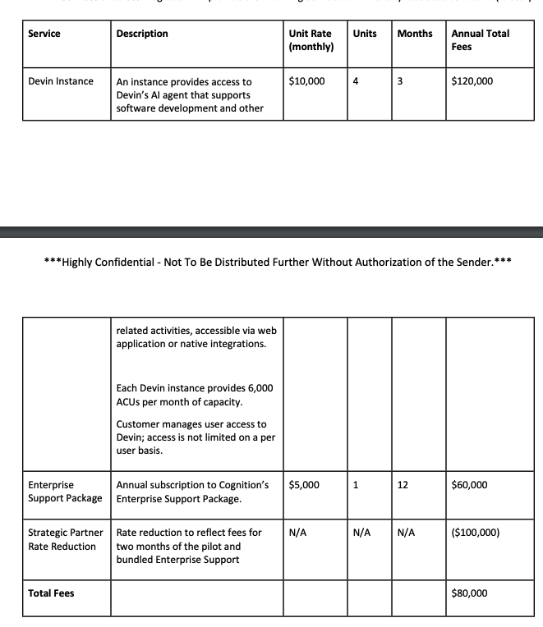

1. **In addition, they also now use a ‘commit consumption’ usage model.** Usage terms in the contract will look like this:

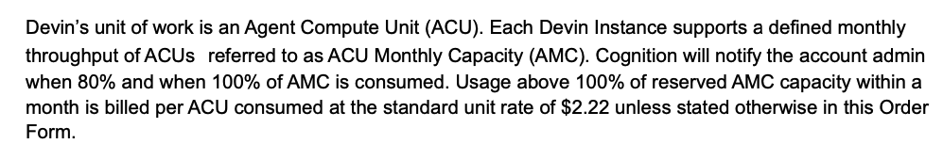

Or this:

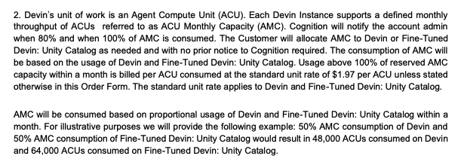

For this model, we will be processing this as standard unit pricing, as they will only be submitted usage data for overages.

1. Process as follows as billing term as follows:
   1. Name: On-demand ACU
      1. Description: Devin OR Fine-Tuned Devin (more details on this below)
   2. Billing type: Unit price
   3. Integration Item: AI License Agent
   4. Event type:
      1. Devin: Devin
      2. Fine-Tuned Devin: Unity_Catalog_Fine_Tuned_Devin
   5. Price: Price stated in the language from the paragraph above (2.22 in first example and $1.97 in second example above)
   6. Start Date: Same as effective state on the contract
   7. Frequency: monthly for the amount of months in the term, specified in initial pricing table
2. Ignore monthly capacity, as they will be tracking this internally.
3. Some contracts might have two different types of ACU capacities outlined, Devin and Fine-Tuned Devin. These might be the same price or they might be different, which will be specified in the paragraph above. Either way, process as two separate billing terms.
4. For Renewal Contracts, process BTs under the renewal contract.
   1. Only process the BTs under the Amended SOW Services section.
   2. Ignore the BTs under Base SOW services
      1. These BTs will already be processed under the original contract

1. Anything to ignore in contracts?
   1. Some old ones mention free trials, please ignore, as they are not part of billing cycle
2. Specifics processing things merchant has requested that may differ by contract (e.g. always back-date invoice date to final day of the month)
3. Default Service Term
   1. If None Listed, Ops Default is 1 Year
4. Default Net Payment Terms
   1. If None, Ops Default is 30
5. Default Billing Frequency
   1. If None Listed, Ops Default is Monthly
6. How do we handle taxes as a line item?
   1. If None Listed, Ops Default is every tax line item becomes a BT

### Events Processing (if necessary)

* Will be API calls if they move to this model

Integration Items Processing (if necessary)

* What are the instructions for assigning integration items?
* Example: All Statsig integrations items should be labeled as “Sales”
* Example: All “Pinata” integration items should be labeled as “Software Subscription Bundle” unless otherwise noted by Merchant

Post Processing Communications (if necessary)

* Does Ops Team need to notify anyone on the team re: completion of processing batches in Implementation or Active phase?
* Who needs to be notified and when?
  + Example:
    - Who: Customer Success [Azmat Aziz] needs to be notified
    - Where: Messari internal merchant channel
    - When: contracts are processed [Merchant Phase: Active]

### Customer Information

* Any important information on specifics customers of this merchant
  + AP Portal automation is important
  + Contract with mostly large ACV enterprises

### Feature Requests

* FR 1
  + AP Portal Automation
  + Work almost exclusively with enterprises and track logins in a google sheet
  + Somewhat urgent - okay with manual work around

### Rewatch Calls

* June 20th, 2024 Disco
  + <https://tabs.rewatch.com/video/zxb7k2i177nb68ss-kyle-nicholas-meeting-june-20-2024>
* July 2nd, 2024 Custom Demo
  + <https://tabs.rewatch.com/video/mxzf8gjn5q6wfc8f-salima-ghadimi-and-nicholas-gatti-july-2-2024>
* July 3rd, 2024 Sandbox Sync and Proposal
  + <https://tabs.rewatch.com/video/sn2606iaxc4a28ui-cognition-tabs-sandbox-sync-and-next-steps-july-3-2024>